# Enabling SUDO rights for WinSCP

The **neon scp** command launches WinSCP with SUDO access to cluster hosts. If for some reason, you need to launch WinSCP directly or against a non-neonCLUSTER host, you’ll need to manually **Enable SUDO** access. By default, WinSCP will not be able to access protected directories and files, even though your login account as admin permissions. You can enable this manually when you create or edit connections:

1. NOTE: For the following to work, sudo on the Linux machine must be configured so that it doesn’t prompt for passwords. The standard neonCLUSTER VM templates and containers are configured this was by default. To accomplish this manually, you need to:  
     
   Edit the **/etc/sudoers** file to prevent sudo from requesting passwords (breaking scripts). Use the following command to edit the file:  
     
   sudo visudo  
     
   and then change the line starting with **%sudo** to:  
     
   %sudo ALL=NOPASSWD: ALL
2. Select **SCP** as the **file protocol** and then click the **Advanced…** button in the connection dialog:  
     
   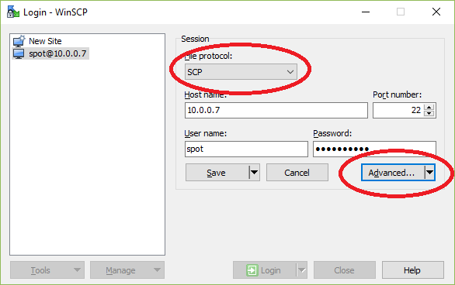
3. Select **Environment/SCP** in the left panel and change the shell command to **sudo bash**.  
     
   